Question 1
Prossessor: Apple silicon (Er í vm)
BIOS Version/Date: VMware, INC
Physical Memory: 6.74 GB
Question 2
(Það var ekki neit sem var listaður undir DMA channels)
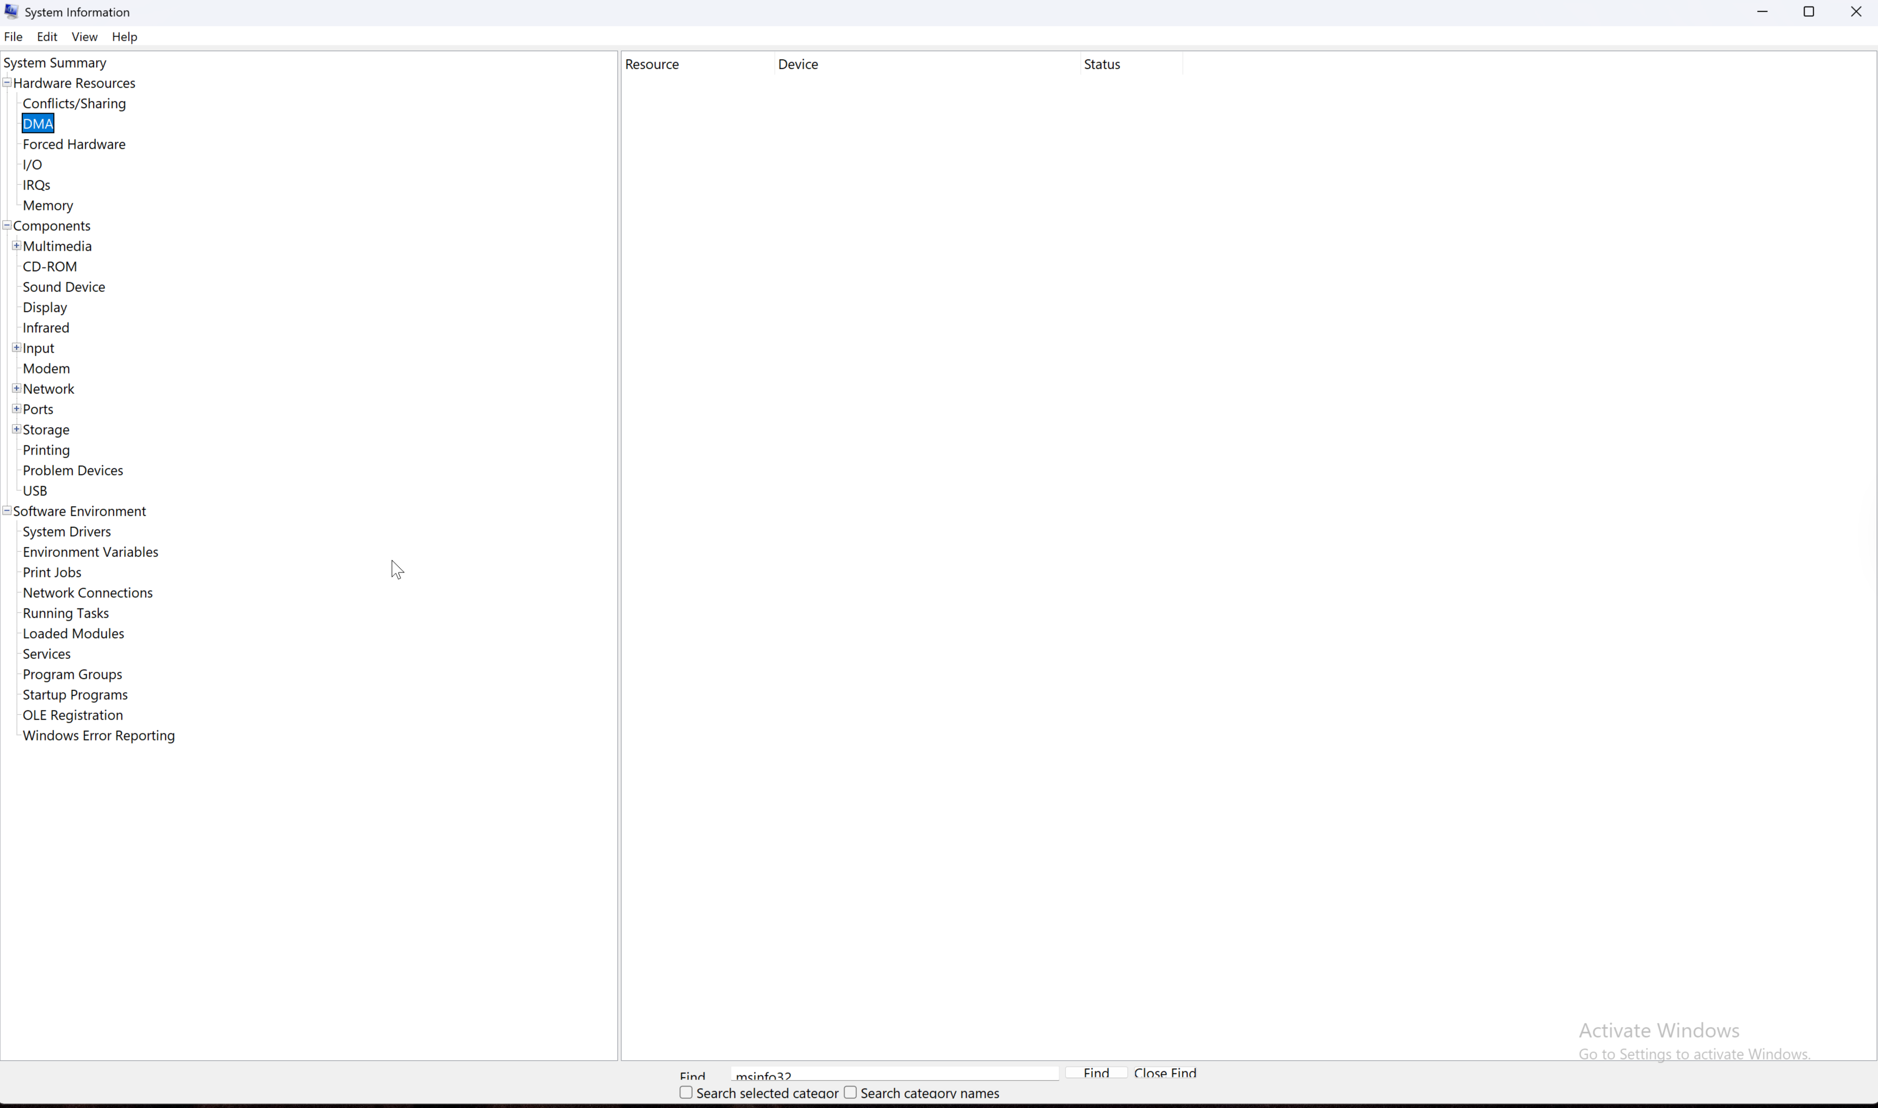
Question 3
Name: [00000000] Microsoft Kernel Debug Network Adapter
Adapter Type: Not Available
Question 4
Its in „starter programs“. Thats where the startup programs are.
Question 5
Yes you can. In fact i can disable everything.
Question 6 a - h
Fjékk leyfi till þess að sleppa því það leitir bara á google þegar er að leita „dxdlag“
Reflection Questions
1 it can improve the systems performance.
2 You would use the Startup tab to control which programs start automatically when Windows boots.

